I-ROCK Test Data Summary Report

Category: Sound Analysis & Testing

Test Preformed: ASTM E413-87 Classification for rating sound insulation

Test Results See Graph Below:

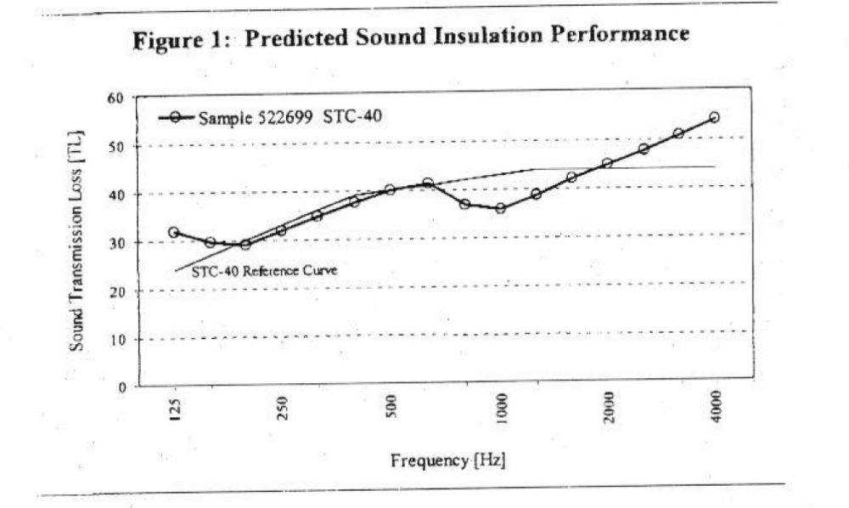

Test Preformed By: HGG Engineering

